A Socially Relevant Project Report on

OTP BASED SMART WIRELESS LOCKING SYSTEM USING ARDUINO

*submitted in partial fulfillment of the requirement for the award of the Degree of BACHELOR OF TECHNOLOGY*

**by**

**S. ABDUL REHAMAN (19AT1A0402)**

**S. ABDUL KABEER (19AT1A0401)**

**S. ARSHAD BASHA (19AT1A0414)**

**T. HARSHA VARDHAN (19AT1A0444)**

**Under the Guidance of**

**Mr. S. SHANAWAZ M.Tech**

**Assistant Professor**



**DEPARTMENT OF ELECTRONICS AND COMMUNICATION ENGINEERING**

**G. PULLAIAH COLLEGE OF ENGINEERING AND TECHNOLOGY**

**(Autonomous)**

(Approved by AICTE | NAAC Accreditation with ‘A’ Grade | Accredited by NBA (ECE, CSE & EEE) |

Permanently Affiliated to JNTUA)

**2019-2023**

**G.PULLAIAH COLLEGE OF ENGINEERING AND TECHNOLOGY**

**(Autonomous)**

(Approved by AICTE | NAAC Accreditation with ‘A’ Grade | Accredited by NBA (ECE, CSE & EEE) |

Permanently Affiliated to JNTUA)

**DEPARTMENT OF ELECTRONICS AND COMMUNICATION ENGINEERING**



**CERTIFICATE**

This is to certify that the A Socially Relevant Project report entitled **“OTP BASED SMART WIRELESS LOCKING SYSTEM USING ARDUINOUSING ARDUINO USING ARDUINO”** being submitted by **S. ABDUL REHAMAN (19AT1A0402), S. ABDUL KABEER (19AT1A0401), S. ARSHAD BASHA (19AT1A0413), T. HARSHA VARDHAN (19AT1A0444)** in partial fulfillment of the requirement for the award of the degree of Bachelor of Technology in Electronics and Communication Engineering of G.Pullaiah College of Engineering and Technology, Kurnool is a record of bonafide work carried out by them under my guidance and supervision.

**Mr. S. SHANAWAZ M.Tech.** **Dr.T.TIRUPAL  M.Tech., Ph.D**

Project Supervisor Head of the Department

Date of Viva-Voice___________

INTERNAL EXAMINER EXTERNAL EXAMINER

**ACKNOWLEDGEMENT**

We are extremely grateful to Chairman, **Sri G.V.M.Mohan Kumar,** of G.Pullaiah College of Engineering and Technology, Kurnool, Andhra Pradesh for their good blessings.

We owe indebtedness to our Principal **Dr.C.Srinivasa Rao, M.E., Ph.D.** G.Pullaiah College of Engineering and Technology, Kurnool for providing us the required facilities.

We would like to express our deep sense of gratitude and our sincere thanks to HOD **Dr.T.TIRUPAL, M.Tech., Ph.D.** Department of Electronics and Communication Engineering, G.Pullaiah College of Engineering and Technology, Kurnool for providing the necessary facilities and encouragement towards the project work.

We thank our project supervisor, **Mr. S SHANAWAZ,M.Tech** for his guidance, valuable suggestions and support in the completion of the project.

We gratefully acknowledge and express our thanks to teaching and non-teaching staff of ECE Department.

We would like to express our love and affection to our parents for their encouragement throughout this project work.

**Project Associates**

**S. ABDUL REHAMAN (19AT1A0402)**

**S. ABDUL KABEER (19AT1A0401)**

**S. ARSHAD BASHA (19AT1A0413)**

**T. HARSHA VARDHAN (19AT1A0444)**

**CONTENTS**

**Abstract** 5

**1. INTRODUCTION 6**

1.1 Block Diagram 7

**2. WORKING 7**

2.1 Components Required 7

2.2 Components Description 9

2.3 Hardware 17

2.4 Software 18

2.5 Application Development 20

**3. PROPOSED MODEL 22**

3.1 Proto Type design 23

**4. EXPERIMENTAL RESULTS 24**

4.1 Testing 25

**5. APPLICATIONS & ADVANTAGES 26**

5.1 Advantages 26

5.2 Applications 27

**6. CONCLUSIONS & FUTURE SCOPE 28**

6.1 Conclusions 28

6.2 Future Scope 28

**BIBLIOGRAPHY** **29-30**

ABSTRACT

Security play’s major role in today’s life; this work mainly deals with security. Here we make use of Bluetooth module, Servo Motor and Arduino microcontroller. The IP Address of authorized person are previously stored in microcontroller, by using matching algorithm we check whether the person is authorized or not. If the person is authorized OTP (One Time Password) has been sent to that authorized person mobile Application using Bluetooth module. The Mobile application brings the interface between the User and Microcontroller integrated with Bluetooth module. If you are still using the key-based system, you are likely to land in a big problem if your key gets lost or stolen. The electronic wireless lock system is not safe either. You might forget the password and there is also a high risk being hacked. Our mobile application will generate random pin code which keep things more secure and safe. This can be implemented to the places where security place major role that is in banks, offices etc. The main aim of this research is to provide high security with low cost, as security plays a major role in our society in almost every sector.

1. **INTRODUCTION**

We are building a Smart Wireless Lock System that uses a One-Time Password for authentication. We are building a Smart Wireless Lock System that uses a One-Time Password for authentication.

Our system will use a One-Time Password (OTP) to authenticate users. OTPs are passwords that are only used once and then discarded. This makes them much more secure than traditional passwords, which can be used again and again.

In order to use our system, the user will need to first register their device. They will then be given a One-Time Password, which they will need to enter into the lock in order to unlock it.

This system is much more secure than traditional locks, which can be easily compromised by thieves. It also eliminates the need for key cards or keys, which can easily be lost or stolen.

- The system can be used to secure any type of door, including home doors, office doors, and garage doors

- The system is easy to use and can be operated using a smartphone or a computer

- The system is secure and can be used to protect against unauthorized access

ARDUINO UNO

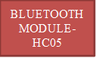

LED

MOBILE

APPLICATION



🖧

POWER SUPPLY

s

**Fig 1.1**- Block Diagram

1. **WORKING**

Before starting this project, we need to get these materials ready first.

**2.1 Components Required**

* Arduino UNO
* Bluetooth Hc05
* LED
* Some Wires/Jumper Wires
* Servo Motor
* 5V Battery/Power Bank
* USB Type B for Programming Arduino

**2.2 Components Description**

# **ARDUINO UNO:**

The Arduino UNO is a standard board of Arduino. Here UNO means 'one' in Italian. It was named as UNO to label the first release of Arduino Software. It was also the first USB board released by Arduino. It is considered as the powerful board used in various projects. Arduino.cc developed the Arduino UNO board.

Arduino UNO is based on an ATmega328P microcontroller. It is easy to use compared to other boards, such as the Arduino Mega board, etc. The board consists of digital and analog Input/Output pins (I/O), shields, and other circuits.

The Arduino UNO includes 6 analog pin inputs, 14 digital pins, a USB connector, a power jack, and an ICSP (In-Circuit Serial Programming) header. It is programmed based on IDE, which stands for Integrated Development Environment. It can run on both online and offline platforms.

The IDE is common to all available boards of Arduino.

The Arduino board is shown below:

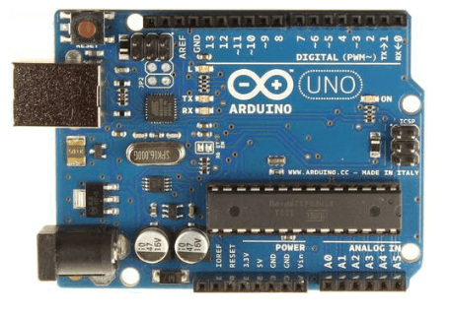

**Fig 2.2.1***-* Arduino UNO

The components of Arduino UNO board are shown below:

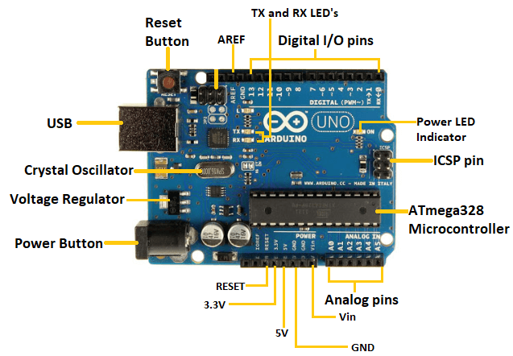

**Fig 2.2.2**– Pin diagram

Let's discuss each component in detail.

* **ATmega328 Microcontroller**- It is a single chip Microcontroller of the Atmel family. The processor code inside it is of 8-bit. It combines **Memory (SRAM, EEPROM, and Flash), Analog to Digital Converter, SPI serial ports, I/O lines, registers, timer, external and internal interrupts, and oscillator.**
* **ICSP pin**- The In-Circuit Serial Programming pin allows the user to program using the firmware of the Arduino board.
* **Power LED Indicator**- The ON status of LED shows the power is activated. When the power is OFF, the LED will not light up.
* **Digital I/O pins**- The digital pins have the value HIGH or LOW. The pins numbered from D0 to D13 are digital pins.
* **TX and RX LED's**- The successful flow of data is represented by the lighting of these LED's.
* **AREF-**The Analog Reference (AREF) pin is used to feed a reference voltage to the Arduino UNO board from the external power supply.
* **Reset button**- It is used to add a Reset button to the connection.
* **USB**- It allows the board to connect to the computer. It is essential for the programming of the Arduino UNO board.
* **Crystal Oscillator**- The Crystal oscillator has a frequency of 16MHz, which makes the Arduino UNO a powerful board.
* **Voltage Regulator**- The voltage regulator converts the input voltage to 5V.
* **GND**- Ground pins. The ground pin acts as a pin with zero voltage.
* **Vin**- It is the input voltage.
* **Analog Pins**- The pins numbered from A0 to A5 are analog pins. The function of Analog pins is to read the analog sensor used in the connection. It can also act as GPIO (General Purpose Input Output) pins.

### **Technical Specifications of Arduino UNO**

The technical specifications of the Arduino UNO are listed below:

* There are 20 Input/Output pins present on the Arduino UNO board. These 20 pins include 6 PWM pins, 6 analog pins, and 8 digital I/O pins.
* The PWM pins are Pulse Width Modulation capable pins.
* The crystal oscillator present in Arduino UNO comes with a frequency of 16MHz.
* It also has an Arduino integrated WIFI module. Such Arduino UNO board is based on the Integrated Wi-Fi ESP8266 Module and ATmega328P microcontroller.
* The input voltage of the UNO board varies from 7V to 20V.
* Arduino UNO automatically draws power from the external power supply. It can also draw power from the USB.

The technical specifications of the Arduino UNO are listed below:

* There are 20 Input/Output pins present on the Arduino UNO board. These 20 pins include 6 PWM pins, 6 analog pins, and 8 digital I/O pins.
* The PWM pins are Pulse Width Modulation capable pins.
* The crystal oscillator present in Arduino UNO comes with a frequency of 16MHz.
* It also has an Arduino integrated Wi-Fi module. Such Arduino UNO board is based on the Integrated Wi-Fi ESP8266 Module and ATmega328P microcontroller.
* The input voltage of the UNO board varies from 7V to 20V.
* Arduino UNO automatically draws power from the external power supply. It can also draw power from the USB.

# **BLUETOOTH HC05 MODULE:**

# **Introduction**

* It is used for many applications like wireless headset, game controllers, wireless mouse, wireless keyboard and many more consumer applications.
* It has range up to <100m which depends upon transmitter and receiver, atmosphere, geographic & urban conditions.
* It is IEEE 802.15.1 standardized protocol, through which one can build wireless Personal Area Network (PAN). It uses frequency-hopping spread spectrum (FHSS) radio technology to send data over air.
* It uses serial communication to communicate with devices. It communicates with microcontroller using serial port (USART).

# **HC-05 Bluetooth Module**

* HC-05 is a Bluetooth module which is designed for wireless communication. This module can be used in a master or slave configuration.

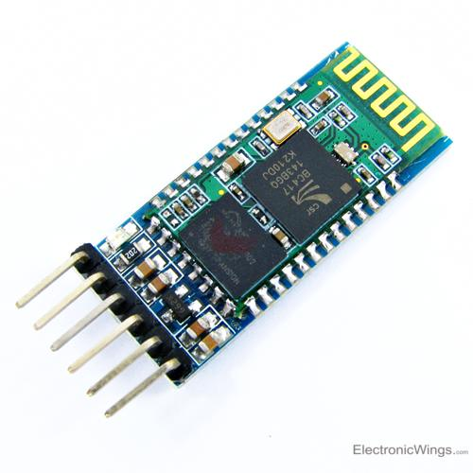

**Fig 2.2.3** – Bluetooth Module

# **Pin Description**

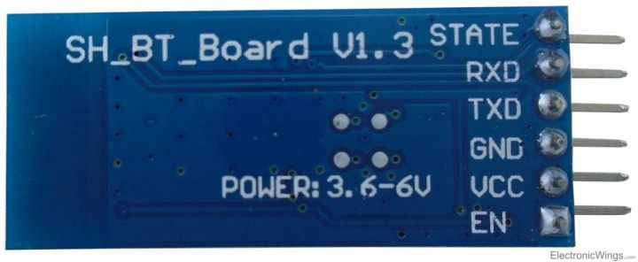

**Fig 2.2.4** – Bluetooth Module pin description

Bluetooth serial modules allow all serial enabled devices to communicate with each other using Bluetooth.

It has 6 pins,

1.  **Key/EN:** It is used to bring Bluetooth module in AT commands mode. If Key/EN pin is set to high, then this module will work in command mode. Otherwise by default it is in data mode. The default baud rate of HC-05 in command mode is 38400bps and 9600 in data mode.

HC-05 module has two modes,

          1.  **Data mode:**Exchange of data between devices.

          2.  **Command mode:**It uses AT commands which are used to change setting of HC-05. To send these commands to module serial (USART) port is used.

2.  **VCC:**Connect 5 V or 3.3 V to this Pin.

3.  **GND:**Ground Pin of module.

4.  **TXD:**Transmit Serial data (wirelessly received data by Bluetooth module transmitted out serially on TXD pin)

5.  **RXD:** Receive data serially (received data will be transmitted wirelessly by Bluetooth module).

6.  **State:**It tells whether module is connected or not.

**HC-05 module Information**

* HC-05 has red LED which indicates connection status, whether the Bluetooth is connected or not. Before connecting to HC-05 module this red LED blinks continuously in a periodic manner. When it gets connected to any other Bluetooth device, its blinking slows down to two seconds.
* This module works on 3.3 V. We can connect 5V supply voltage as well since the module has on board 5 to 3.3 V regulator.
* As HC-05 Bluetooth module has 3.3 V level for RX/TX and microcontroller can detect 3.3 V level, so, no need to shift transmit level of HC-05 module. But we need to shift the transmit voltage level from microcontroller to RX of HC-05 module.

# **LED LIGHT**:

A light-emitting diode (LED) is a semiconductor light source that emits light when current flows through it. Electrons in the semiconductor recombine with electron holes, releasing energy in the form of photons.

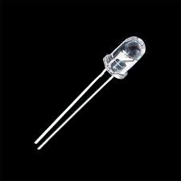

**Fig 2.2.5** – LED light

# **SERVO MOTOR:**

A **servo motor** is a type of motor that can rotate with great precision. Normally this type of motor consists of a control circuit that provides feedback on the current position of the motor shaft, this feedback allows the servo motors to rotate with great precision. If you want to rotate an object at some specific angles or distance, then you use a servo motor. It is just made up of a simple motor which runs through a **servo mechanism**. If motor is powered by a DC power supply, then it is called DC servo motor, and if it is AC-powered motor then it is called AC servo motor. For this tutorial, we will be discussing only about the **DC servo motor working**. Apart from these major classifications, there are many other types of servo motors based on the type of gear arrangement and operating characteristics. A servo motor usually comes with a gear arrangement that allows us to get a very high torque servo motor in small and lightweight packages. Due to these features, they are being used in many applications like toy car, RC helicopters and planes, Robotics, etc.

Servo motors are rated in kg/cm (kilogram per centimetre) most hobby servo motors are rated at 3kg/cm or 6kg/cm or 12kg/cm. This kg/cm tells you how much weight your servo motor can lift at a particular distance. For example: A 6kg/cm Servo motor should be able to lift 6kg if the load is suspended 1cm away from the motors shaft, the greater the distance the lesser the weight carrying capacity.  The position of a servo motor is decided by electrical pulse and its circuitry is placed beside the motor.



**Fig 2.2.6**- Servo motor

### **Servo Motor Working Mechanism**

It consists of three parts:

1. Controlled device
2. Output sensor
3. Feedback system

It is a closed-loop system where it uses a positive feedback system to control motion and the final position of the shaft. Here the device is controlled by a feedback signal generated by comparing output signal and reference input signal.

Here reference input signal is compared to the reference output signal and the third signal is produced by the feedback system. And this third signal acts as an input signal to the control the device. This signal is present as long as the feedback signal is generated or there is a difference between the reference input signal and reference output signal. So, the main task of servomechanism is to maintain the output of a system at the desired value at presence of noises.

# **JUMPER WIRES / SOME WIRES:**

Jumper wires are simply wires that have connector pins at each end, allowing them to be used to connect two points to each other without soldering. Jumper wires are typically used with breadboards and other prototyping tools in order to make it easy to change a circuit as needed. Fairly simple. In fact, it doesn’t get much more basic than jumper wires.



**Fig 2.2.7** – Jumper wires

# **9V BATTERY:**

The nine-volt battery, or 9-volt battery, is an electric battery that supplies a nominal voltage of 9 volts. Actual voltage measures 7.2 to 9.6 volts, depending on battery chemistry. Batteries of various sizes and capacities are manufactured; a very common size is known as PP3, introduced for early transistor radios. The PP3 has a rectangular prism shape with rounded edges and two polarized snap connectors on the top. This type is commonly used for many applications including household uses such as smoke and gas detectors, clocks, and toys.



**Fig 2.2.8** –9v Battery

# **2.3 HARDWARE:**

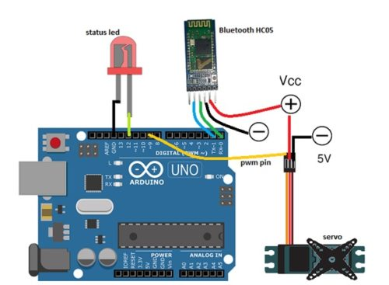

**Fig 2.3.1** – Connecting circuit

Let’s connect the components as per the circuit diagram shown above. You might not like to fry costly Arduino board with the wrong connection. So, always crosscheck your setup to ensure that all connections are ok.

### **2.4 TABLE:**

2.4.1- Arduino Pins and Components Pins.

### **Connecting Components:**

|  |  |
| --- | --- |
| **Arduino Pins** | **Components and Pin** |
|  |  |
| Arduino Pin 9 (p.m.) | Servo Yellow Wire (signal input wire) |
| Rx | Bluetooth Module TX |
| Tx | Bluetooth Module RX |
| GND | GND Bluetooth |
| VCC | Bluetooth VCC |
| Pin 12 | LED |
| GND | Battery(-VE) |

# **2.5 SOFTWARE:**

For Software Implementation we will be using Arduino Software in order to dump the code in microcontroller i.e., Arduino UNO.

First, we need to include the library and declare variables needed, as in snippet of code. We include a servo library, then create a string array to generate a password. After this, we need to create a few more string variables to store password, OTP and LED pin numbers as in snippet Fig.1 of code.

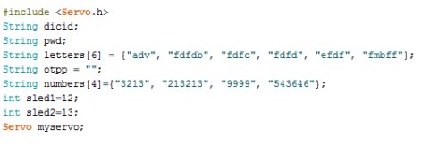

**Fig.2.5.1** – Include Library Code

In the second part of coding, we need to set up serial and Braud rate for Bluetooth. Here I have used 9600 Braud rate but if it didn’t work, you can use default Braud rate of Hc 05 i.e. (38400). Then, we have to set up a pin for servo using servo. Attach (PWM pin number). After that, we can define pin mode as output for led refer (Fig.2)

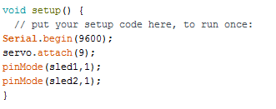

Fig.2.5.2 – Setting up serial and Braud rate of Bluetooth

In the third part of code, we will create a loop and check the data coming from Bluetooth. Then we create if() statement to check device id. If it matches, then it calls opt() function for generation of OTP (refer Fig. 3)

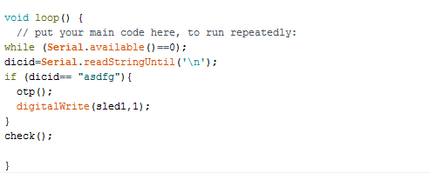

**Fig.2.5.3** – Creating Loop

Then we need to create check()  function to check whether OTP is correct or not. If it is correct then it turns servo to open position (refer Fig. 4).

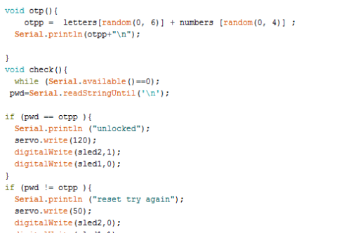

Fig.2.5.4 – Creating Function Operations

Now we are done with the coding part and we can Dump the code in the Arduino UNO via USB- Type B cable which is connected between Arduino UNO and Laptop/Computer/Mobile.

Now, let’s make Android APP for our project. We can make App with two different platforms, either Android Studio or MIT app inventor. For this project, let’s choose **the MIT app inventor** because it’s easy to make an App with blocks without coding.

# **2.6 APP DEVELOPMENT:**

The below is the figure is the App Interface of MIT app inventor. We just need to drag and drop elements needed in the application. It’s easy to use, User Friendly. As per about our app we need 2 buttons which are clickable and responsible.

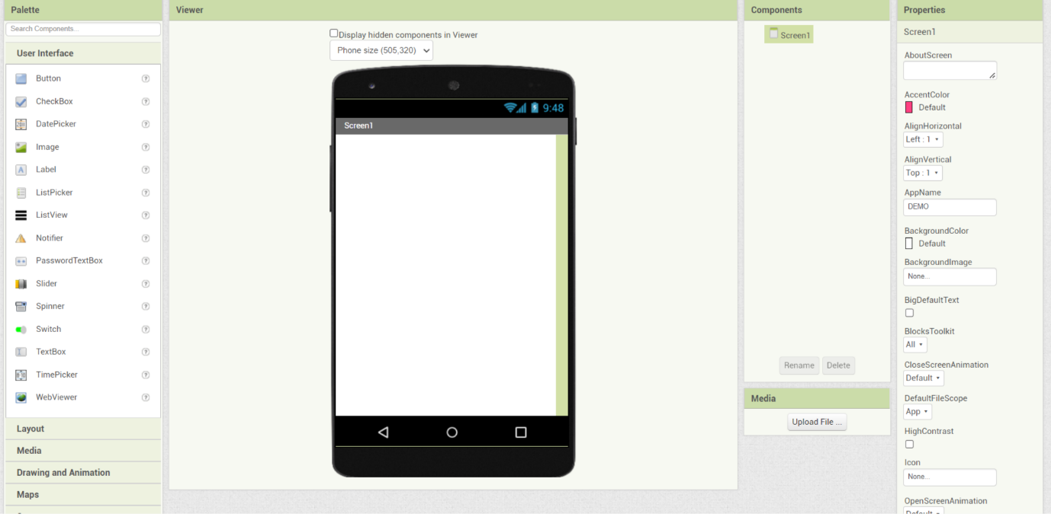

**Fig.2.6.1** - MIT app inventor Interface*.*

Now let’s get into the code Blocks tab, for coding.

First, we need to initialise Bluetooth list available for connection. Then we have to set button function to send device id according to our Arduino Code as in the pic below (Fig. 6)

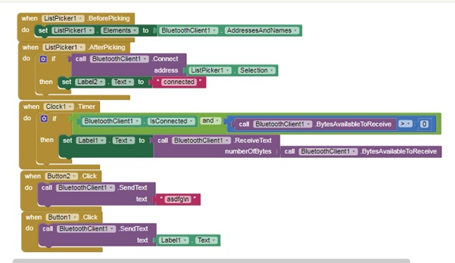**Fig.2.6.2** - Blocks in MIT app inventor

1. **PROPOSED MODEL**

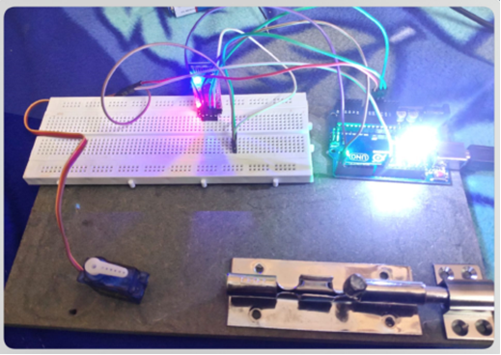

**Fig.3.1** – Proto Type Model

This is our proposed model of this project. We have used bread board to connect the circuit which helps to understand easily. First, connect the Arduino and components to a power supply. Here we have used a 5V Power Bank for Arduino is a great tool for anyone looking to get into electronics and programming. We are going to show you how to connect your Arduino to a power supply and a Bluetooth module so you can control it wirelessly with your smartphone.

First, connect the Arduino and components to a power supply. Here I have used a 5V Power Bank for it. Next, open the installed App, then turn on the Bluetooth of the phone. When you tap on the Bluetooth icon, you will get the list of Bluetooth connections for pairing. Now, tap on HC 05. On successful pairing, you will get a ‘connected’ message on the App.

Now, you can start sending commands to the Arduino via the App. For example, you can turn on/off an LED connected to one of Arduino's digital pins. To do this, simply tap on the ON/OFF button in the App.

That's all there is to it! With a few simple steps, you can control your Arduino wirelessly with your smartphone.

1. **EXPERIMENTAL RESULTS**

This is how our Mobile application looks like. After successfully creating the application now export the file in .apk format, which is used to install the application for any of devices.

### **4.1 Testing:**

First, connect the Arduino and components to a power supply. Here I have used 5V Power Bank for it. Next, open the installed App, then turn on the Bluetooth of the phone. When you tap on the Bluetooth icon, you will get the list of Bluetooth connections for pairing. Now, tap on HC 05. On successful pairing, you will get a ‘connected’ message on the App as in Fig 8.

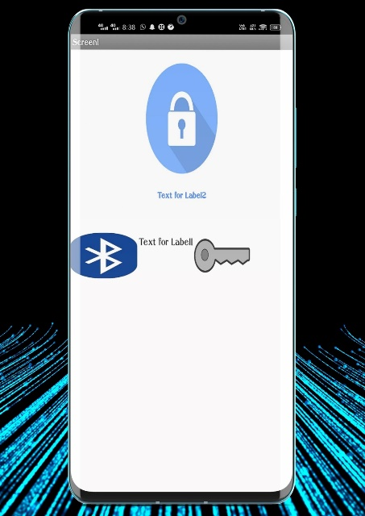 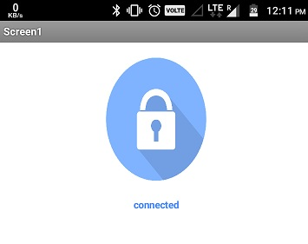

**Fig.4.1(a)** – App Interfacing **Fig.4.1(b)** – Successfully Connected

After that, tap on the key icon to send device id to match. If the device id is matched, it will send an OTP to your app that you can see in App text bar between Bluetooth and lock icon.

Now, you can tap on the lock icon to unlock your Smart Lock. If everything is ok then servo moves unlocking mechanism and onboard LED of Arduino lights up indicating successful unlock. I have used servo because of its high torque, and also because we can control the angle of its movement that helps in unlocking mechanism of the lock.

1. **APPLICATIONS & ADVANTAGES**

**5.1 ADVANTAGES:**

**1)Increase Accessibility Without Compromising Security:**

* House keys are often misplaced. To avoid tracking down keys or changing the locks when tenants move out, consider smart locks with keypads. With models such as the HC05, you can unlock the door with your smartphone using Bluetooth technology. You can also assign your children their own passcodes to monitor their entry and exit.

**2) Smart Locks Are Accessible Via Smartphones:**

* Virtual keys give easy access to vacation rental guests, visiting relatives and aging family members. Smart locks are a great addition to other devices you control remotely. From smart lights and smart appliances to your home entry system, smart devices are the way of the future — stay ahead of the curve.

**3) Simplify Home Security:**

* Smart keys let you grant access to multiple people and track who comes in and out of your home any time of the day or night. By downloading the Mobile app, you can remotely monitor and control your home’s smart locks and assign new passcodes when needed

**4) Boost Your Connectivity:**

* Integrate your smart locks into your home security system by downloading the app onto your in-home or mobile device. If family members or house guests forget to lock the door after exiting, smart locks can activate the locking mechanism! That’s a relief when you’re halfway to Starbucks and wonder if you forget to lock the front door — again! It could also help you stay out of the doghouse with your spouse.

* 1. **APPLICATIONS:**

1. This project can be used in different places such as houses, Offices, Schools/ University and Especially in banking sectors.
2. Its more safe and secure as it generates random Otp every time we try to enter into any place. Whereas the traditional lock system and as well as electronic lock system are not much secure than of this device.
3. It’s cheaper than of Traditional and Electronic Locks with more Effective and Reliable characteristics which makes it more popular and demanded product in current scenario.
4. **CONCLUSIONS & FUTURE SCOPE**

Present era has witnessed home automation and related applications as a growing trend. It is a technology that remolds the manual work to the automation in order to enhance luxury, comfort and standard of living thereby making human life much easier, better and more secure. This paper presents an idea of keyless smart home and an application of home automation. The proposed approach resolves problems presented by conventional metal locks of existing doors I-e vulnerability to break in’s, the space carried by the lock and human efforts required to open/close the door manually.  Moreover, the implementation rate of developed system is very low there by making it affordable for a common person. As compared to most of the existing systems, as discussed in literature review, the keyless smart home is easier to install and maintain. It supports mobile technology and open-source android system platform. The proposed approach is realized using Bluetooth technology for connectivity, android based smart phone App for end user access and user credentials for security and authentication. ARDUINO microcontroller, Bluetooth module, servo motor, male and female wires and front-end android app were interfaced and integrated to realize the desired architecture. In future the designed system can be extended to embrace other aspects of home automation and security. Furthermore, this research work can be enhanced to support other OS platforms apart from android.

**BIBLIOGRAPHY**

1] G. Himaja, B. Rambabu, B. Malakonda Reddy

“Providing Security for ATMs Using Digital Image

Processing for Abnormal Incident Detection”

, International Journal of Advanced Research in

Computer Science and Electronics Engineering

(IJARCSEE), Volume 2, Issue 4, April 2013.

[2] Seung-Soo Shin, Kunefe Han, Kwang-Yoon Jinn,

“Digital Door Lock on the Access Control System

using OTP-based User Authentication”

, International Journal of Digital Content

Technology and its Applications (JDCTA), Volume 7,

Number 11, July 2013.

[3] Applications (, “Design and

Implementation of Security Systems for Smart

Home based on GSM technology”, International

Journal of Smart Home, Vol.7, No.6 (2013).

[4] A.O. Oka, O.M. Olaniyan, O.T. Arul Ogun, O.M.

Olaniyan “DEVELOPMENT OF A

MICROCONTROLLER - CONTROLLED SECURITY

DOOR SYSTEM.” The Pacific Journal of Science and

Technology, Volume 10. Number 2. November 2009

(Fall).

[5] Srinivasa Ravi, Gahagan, Vamsi,

Prettyish”

International Journal of Innovative Technology and

Exploring Engineering (IJITEE), Volume-2, Issue-5,

April 2013

[6] Lia Camelia, Alfin Noor Hassan S.R, Made Sanjaya

and W.S., Edi Mulan, “DOOR-AUTOMATION

SYSTEMUSINGBLUETOOTH-BASED ANDROID

FOR MOBILE PHONE”, ARPN Journal of

Engineering and Applied Sciences , VOL. 9, NO. 10,

OCTOBER 2014

[7] NikhilAgarwal,G. Subramanya Nayak,

“MICROCONTROLLER BASED HOME

SECURITYSYSTEMWITHREMOTE MONITORING”,

International Conference on Electronic Design

and Signal Processing (ICEDSP),2012.

[8] Saurabh VinayakLawate,M.S.Ali, “ELECTRONIC

EYE FOR SECURITY SYSTEM”,International

Journal of Electronic and Electrical Engineering,

Volume 7, Number 9 , 2014.

[9] Raghu Ram.Gangi, Subhramanya Sarma.Gollapudi

,“LOCKER OPENING AND CLOSING

SYSTEMUSING RFID,FINGERPRINT, PASSWORD

AND GSM”,International Journal of Emerging

Trends & Technology in Computer Science

(IJETTCS) , Volume 2, Issue 2, March – April 2013.

M. R. Navya* and Prakash Ramachandran

“DEVELOPMENT OF SECURED HOME

AUTOMATION USING SOCIAL NETWORKING

SITES” , Indian Journal of Science and Technology

Vol 8(20), IPL0116, August 2015

1] G.Himaja, B.Rambabu, B.Malakonda Reddy “Providing Security for ATMs Using Digital Image Processing for Abnormal Incident Detection” ,International Journal of Advanced Research in Computer Science and Electronics Engineering (IJARCSEE) ,Volume 2, Issue 4, April 2013.

[2] Seung-Soo Shin, Kun-Hee Han, Kwang-Yoon Jin, “Digital Door Lock on the Access Control System using OTP-based User Authentication” ,International Journal of Digital Content Technology and its Applications(JDCTA), Volume 7, Number 11, July 2013.

[3] Jayashri Bangali and Arvind Shaligram, “Design and Implementation of Security Systems for Smart Home based on GSM technology” ,International Journal of Smart Home, Vol.7, No.6 (2013).

[4] A.O. Oke, O.M. Olaniyi, O.T.Arulogun, O.M. Olaniyan“ DEVELOPMENT OF A MICROCONTROLLER - CONTROLLED SECURITY DOOR SYSTEM.” The Pacific Journal of Science and Technology, Volume 10. Number 2. November 2009 (Fall).

[5] K.Srinivasa Ravi, G.H.Varun, T.Vamsi, P.Pratyusha,“RFIDBASEDSECURITYSYSTEM” International Journal of Innovative Technology and Exploring Engineering (IJITEE), Volume-2, Issue-5, April 2013

[6] Lia Kamelia, Alfin Noor hassan S.R, Mada Sanjaya and W.S., Edi Mulyana , “DOOR-AUTOMATION SYSTEMUSINGBLUETOOTH-BASED ANDROID FOR MOBILE PHONE” , ARPN Journal of Engineering and Applied Sciences , VOL. 9, NO. 10, OCTOBER 2014

[7] Nikhil Agarwal,G. Subramanya Nayak, “MICROCONTROLLER BASED HOME SECURITYSYSTEMWITHREMOTE MONITORING”, International Conference on Electronic Design and Signal Processing (ICEDSP),2012.

[8] Saurabh Vinayak Lawate ,M.S.Ali, “ELECTRONIC EYE FOR SECURITY SYSTEM”, International Journal of Electronic and Electrical Engineering, Volume 7, Number 9 , 2014.

[9] Raghu Ram.Gangi, Subhramanya Sarma.Gollapudi ,“LOCKER OPENING AND CLOSING SYSTEMUSING RFID,FINGERPRINT, PASSWORD AND GSM”,International Journal of Emerging Trends & Technology in Computer Science (IJETTCS) , Volume 2, Issue 2, March – April 2013. M. R. Navya* and Prakash Ramachandran “DEVELOPMENT OF SECURED HOME AUTOMATION USING SOCIAL NETWORKING SITES” , Indian Journal of Science and Technology Vol 8(20), IPL0116, August 2015.